Jim has me thinking about the writing of his life, so I’ll highlight some of the events that I can recall:

My earliest recollection is that my life started in Cleveland Heights.
Our house had a sunroom with wicker furniture, a piano, and a brand- new Majestic Superhetrodyne radio. This was a floor model, before transistors, powered by vacuum tubes, giving off lots of heat, At that time, a “superhet” was an indication that we had “arrived!!”

Every Easter morning Mom would take us to the bedroom window to watch the trumpeters standing on a parapet at the church saluting the Easter morning.

I recall we lived only a few blocks from Nela Park…

At Christmas, we’d journey to the end of the street, and Nela Park. . This facility was the part of General Electric that did light bulb experiments and design. Our Nela Park trip was to see a wonderful Christmas display. In season, cars packed with families lined up for miles to wait their turn to drive slowly thru the display. In the cars, kids jumped up and down with excitement. (Remember, this was in the 30’s – no TV, and limited radio –this was a BIG EVENT)

The vacant lot next door, was where we kids hung out all day
I roughhoused with my friends in that lot, and broke my leg. The friends brought me home in a wagon. I was sitting in the wagon with the leg up, and kids were walking in front, sides, and rear, carrying a flag!! Sort of a parade !! This had been a green stick fracture—I don’t recall a lot of pain, but I did get a cast, and lots of attention.

Also an early lesson in “milking it”………

(note: in that life, a kids goal was being outside. If a person was to be punished for some alleged misdeed, he was “kept in” ---how times change..)

Our cousin, Stan DeVille, was on the scene quite often. It could be possible that he lived with us a short time while he attended Medical School.

Stan taught me how to tie my shoes. (what an odd recollection! ) I guess that without Stan’s mentoring, I’d be shoeless today

Dad had a Buick. The battery was boxed in at the end of the rear seat, and because of that, only two could sit in the rear. One day he drove home with a brand -new car (a Model A Ford). All the neighbors came over to see the new car.. Windows that rolled up and down, two windshield wipers, gas gauge on the dashboard, engine temperature gauge on the radiator. and new cloth seats. Two windshield wipers indicated the DeLuxe model!!

Dad’s business was called Kinsner Brothers Company, located at 7012 Wade Park.. Brother Jim and I always wondered who the “brothers” were. We know that a partner was named Cy Deitrich (sp). The business was selling and installing new furnaces, and roof repair and installation. At one time the payroll was the partners and three employees. The building housed the showroom (furnaces) and workshop. There was rental apartment upstairs

A large building to the rear stored materials and ladders. A smaller building was called “the paint shed”.

The main building was pretty overwhelming for a nine year old: Big cutters that could shear a 4’ x 4’ sheet metal piece by pushing one lever. Jigs and fixtures to crimp, corrugate and clamp metal just by turning a crank. The washroom was interesting---way up high, on the wall, was the water tank. When one “flushed”, the water came cascading down with a tremendous roar.

Exciting: Sometimes I’d stand there and operate that old commode three or four times!!
.

A baseball field, called League Park was nearby. The Wade Park Spaghetti house (restaurant) was a block away from Dad’s business. This was the hangout for the Cleveland Indians ball players The bartender was Joe Cavoli; Later, after League park closed, Joe and some players opened a restaurant, Cavolis ,on Clifton Blvd, just east of W 117th.

A dinner at Cavoli’s always guaranteed a sighting of at least one recognized sports figure.

The ballplayers were just “good guys”, no agents or promoters. At that time, they were paid only a few thousand dollars per year; in the winter they worked at other jobs to supplement their income.

One day Dad brought me a ball signed by Earl Averill, Joe Vosmik and Lefty Weisman (the trainer) -- guys who “hung around” the restaurant. With that ball, I was the envy of the neighborhood,,,,

Back to the family: ---

At this time in my story, we are still living in Cleveland Heights…

Funny how some memories stay with one forever…..

When Mom was in the hospital, busy having my new brother grandma Streitberger baby-sat. One morning she made French Toast; I would not eat any old “foreign toast” Grandma persevered, however, and it appeared that it would be eat or go hungry. Of the two options it was an easy choice. it was good --one of my favorite breakfasts for several years

Dad brought “baby Jim” home from the hospital, and on seeing me, Mom said “my, Jack is getting so tall!!” I stood straight and was immensely proud. Our father said “he’s not tall, you’re just used to looking at babies”.

Bummer !!.

I started at Caledonia School, in Cleveland Heights, and to this day it is rated one of the best schools in that area. My teacher was Miss Applegate, and I had a crush on her

We then started moving….

We moved out of the house on Helmsdale in Cleveland Heights. It’s possible that the bank foreclosed, or that we tried to rent both parts of the duplex to supplement our income. Remember, this was time of the Depression.

East Cleveland was the next location

The East Cleveland house, on Melbourne, was a bungalow, next to a Congregational Church. Our school was Rozelle, about a four block walk from home

Our class had one black student –Frederick Jones.. when Fred chose a new friend, he was obliged to bring the new acquaintance home to meet his Mother. If Mrs Jones approved of his new friend, he was allowed to play with him.

That was 70 years ago: today the area is all black.

Times change.

The time at Rozelle was pretty unimpressive -- one day a flatbed truck came to school carrying a cow to show kids in East Cleveland a live cow. Jim and I were pretty savvy about cows. and we impressed our friends with our vast knowledge. We knew where the milk came from, what cows ate, and other important bits of information..

Because of “summering” in Avon Lake we’d seen cows. (Avon Lake Village was mostly farms) wow, we were just so knowledgeable !!

Our time in East Cleveland consisted of a nine month year ’cause
we “summered” at grandfathers cottage in Avon Lake. More about the cottage later---

While living on Melbourne, Jim and I started building “apartments”. . I’d get wooden orange crates from the store, and put them on end, on top of each other with planks in between. This made sort of two separate “towers”. The tower “apartments” got so high that Jim and I were on a level with the dining room windows, six feet above ground !!

This shaky, fragile, construction upset Mom and she made an offer;
If we’d promise not to build any more :”apartments”, mom would buy us a tent.

Sucha deal!

The tent arrived and Jim and I proceeded to badger Mom to let us camp out. Camping out meant taking blankets, cookies, a flashlight and milk for our camping trip, ten feet from the house.

Strange sounds in the night. ………….. It got dark, Jim and I heard ominous, creepy sounds. – sorta like ghosts, maybe. We reassured each other that we were not afraid. We panicked and left the tent in the dead of night (like 9:00 p.m) and bolted for the house,.

Jim was the first to “chicken”. (remember, I’m telling this story)

After foreclosing on the Helmsdale house, the bank foreclosed on the Melbourne house. We then moved to the apartments on Superior, Avenue, also owned by our grandfather. That move meant only carrying our furniture from the house to the building, about 40 yards away.

The move to the Superior building apartment was in the early ‘30s

I call the building the apartments, but they weren’t. The building had at street level, one bakery and one meat market. Above each store was an apartment. Each apartment had two bedrooms, one bath, a kitchen and dining room. The building fronted on Superior Avenue.

The Superior Streetcar line ended at 120th car barn. If you wanted to get a Euclid Streetcar, you took the dinky” to go from 120th to the Euclid Line. This connecting “dinky” was a little streetcar with a motor man’s control at each end. There was only one track, so when the dinky got to the end of its line, the motorman walked to the other end of the car to drive. What had been the back, now became the
front.….”

On the roof of the bakery, grandpa Streitberger had built a large shed. One of his children had breathing problems, and it was thot that fresh air would be good for him. This, then became a sort of clubhouse – we had makeshift bunks and would some times sleep there overnight.

At the apartment, we lived simply. Food was kept cool in the ice box. Electric refrigerators were an unknown. An icebox was an insulated box with a separate compartment for a block of ice. Food was kept in a compartment below: the “cool” from the ice trickled from the upper box A card would be placed in the window for the ice truck. The iceman would deliver 25, 50, or 75 pound block of ice – whatever the card indicated. Melting ice kept the food cold.

In winter, food was kept cold in a window box. This box extended through a window to the cold outdoors. There was no temperature control -- if it got very cold the milk would freeze and rise out of the top of the bottle Milk was delivered in glass bottles, when empty, were returned for credit

We lived in one apartment and rented the other. The other was rented by a family with the father working for the Cleveland Railway System (Streetcars) Depression time -- Cleveland Railway had no cash, and they paid their employees in script. Script was paper money—sort of a promise to pay “ when we get some money we’ll redeem the script for cash”.

In depression times jobs and money were scarce

I thought selling magazines would be a great way to make money so I began with the Saturday Evening Post. and Liberty magazines. I’d walk down to where the Superior Streetcar Line ended, and hawk the magazines to those riders emptying the street cars. Jim, only six, all bundled up, would traipse along with me. This was wintertime (cold) and the magazine business was slow. I gave this up after about four or five “tries”. with no sales

At the time we were still living in Cleveland we vacationed at the cottage in Avon Lake, on Rosewood Drive

The cottage, belonging to Grandpa Streitberger, located on the lake shore, was on five acres, called the Bakers Allotment.

Ten bakers had banded together in the 20’s and purchased the land, fronting on Lake Erie. On this land each family built a summer cottage. In addition to the cottages, they built a tennis court, horseshoe pits, three piers into the lake, and a large clubhouse. The clubhouse was host to clambakes, parties, and all-night poker games. The bakers had been successful and planned together to enjoy the summers away from Cleveland They all had immigrated from Germany ----- with names like Streitberger, Luthhart, Dietrich, Weber…….

Those summers were idyllic and I continually begged our dad for us to leave East Cleveland and move to Avon Lake permanently. The pleas went unheeded, until--

In 1936 the banks foreclosed on the last of the Streitberger Cleveland properties. The cottage in Avon Lake was paid for, so we moved to Avon lake.

The Avon Lake “house” was a summer cottage, with a sunroom, dining room, one bedroom and a kitchen. Jim and I slept in he bedroom, and Mom and dad slept in a daybed in the sunroom..

Our first winter in Avon Lake. was challenging: We had no inside walls in the kitchen and where the nails stuck thru from the outside, one could see frost. The water lines froze, and a man came with a transformer and connected wires to each end of the pipe., powered up, and very shortly. steam came out of the faucet, followed by water.

Our house heat was a coal-burning stove in the dining room –on cold mornings Jim and I would stand near the stove to keep warm while dressing for school. The stove burned coal or wood. I suggested we could cut up street car track ties for the wood. This was a bad idea--- the ties were full of gravel –could not be sawed.

Avon Lake had one school building; grades one thru twelve. Grades one thru six on the first floor, and seven thru twelve on the second.

We had 42 kids in our class.

As a matter of record, population of Avon Lake:

- 2600

Three school busses served the entire village, driven by Mr Doughty, Mr Krebs, and Mr Walker. Mr Doughty had the Lake Road route, and if Jim and I were late, he’d honk his horn and wait for us We were at the beginning of his route, so the bus never really got warm until we got off. at school

One of the drivers, Mr Walker,had a farm. On Monday mornings the school bus smelled like chickens. We kids insisted he used the bus for a week-end chicken coop !!

Jim’s and my first day at the school was memorable: I was 11, and Jim was six years old. At the first recess he walked in front of Gene McCowan who was on a swing..Of course walking in front of the swing, Jim got knocked down. I was ready to fight Gene. As I approached, ready to do battle, Gene said “:why are you mad at me –he walked into the swing “

No argument there…..

The industrial arts class was held in a large rickety wooden building on the playground. I don’t remember any classes, and I don’t remember any good tools either. There were some wood chisels, and we’d throw them at the wall to make them stick. I don’t remember the grade for my “marksmanship”

This was depression, and the WPA came and added a new science lab, music room and industrial arts room.

I was active during my ‘teen years: Trumpet in the band, the orchestra, glee club, JV basketball, Boy Scouts, drum and bugle corps and a morning paper route.

According to the journal I kept, the route was six miles long and I had 40 daily customers. Daily Plain Dealer’s were 3 cents; the Sunday was ten cents. I made a penny on the daily and two cents on the Sunday.

Dad would let me use the car to deliver the heavy Sunday papers. Jim, who was ten, would deliver the papers from the car, and if you believe him, all I did was sit in the car and yell “run faster”.

In 1940 I went into the lawn mowing business. I bought a Cooper Clipper mower for $67.00, new.

Other kids were pushing a lawnmower for, as I remember, 35 c an hour. I solicited business, at 50c** per hour and was successful. If a potential customer asked why I charged “a lot more”, my response was that the kids pushing had to stop and rest often. My mower was
powered, I didn’t need to stop and rest, so actually, I could be finished in a shorter time – so, less payout for the customers

And –

Less work for me !!

It worked -- in the growing season I was cutting lawns six days a week – not pushing a mower, but following, and making money !!

Our nearest year –round neighbor was the Foote family; Mr and Mrs., and Bill and Barb. ( “nearest” meant a quarter mile away)…Before moving to Lake Road they had a small house off Curtiss. The Lake Road move left the small house empty. In the winter Bill and I would go to the small house, build a fire in little stove, and play ping-pong for hours

In summertime--

The Foote family walked down Edgewood drive (no houses on the street, then) to the Lake. I’d meet Bill, and join the group. At that time there was a large abandoned bathhouse at the end of the street.

This belonged to the Belmar Beach Ass’n.The bathouse had a long porch acrss the front, with benches to sit and view the lake. Inside were “changing stalls” Past the bathhouse to a (then) sandy beach.
We had the whole beach area to ourselves

Mr Foote was an engineer and designed a sturdy raft. The raft platform was supported by six 55-gallon drums, four in line and two on side for stability.

Bob Marimon and I had heard talk about a tug sinking off the Rosewood Drive area. We located and marked the remains of this wreck. One day we pushed the raft to the tug location and proceeded to do salvage diving.

Standing on top of the wreck, we could keep our nose just above water, take a deep breath, and dive down to the tug. Ballast for the tug was 35# pig iron bricks. Bob and I would dive down, retrieve a brick, and throw it on top of the raft. Being of strong bodies, and not very strong mind, we then off loaded the bricks to the shore. Then parked the raft and carried the bricks upstairs to a vacant lot on Rosewood. Later we sold these to junk man for spending money. I did keep one “brick”; it’s in my workshop and I use if for an anvil.

The great salvage job led to another endeavor -- the building of a genuine diving helmet ( I have two pictures of this). Bob Hallenburg and I went to the Rocky River dump and got an old fashioned sidearm hot water tank. Lots of cutting and welding led to completion of a genuine diving helmet, complete with window (cut from the windshield of a Model A ford) We couldn’t afford an air pump, so it never really got tested. The helmet, did get lots of mileage, however.

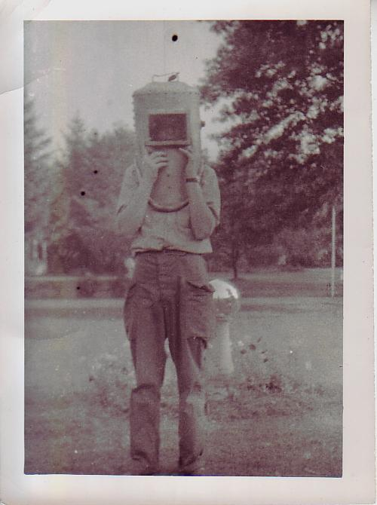

Jack, “in” the diving helmet
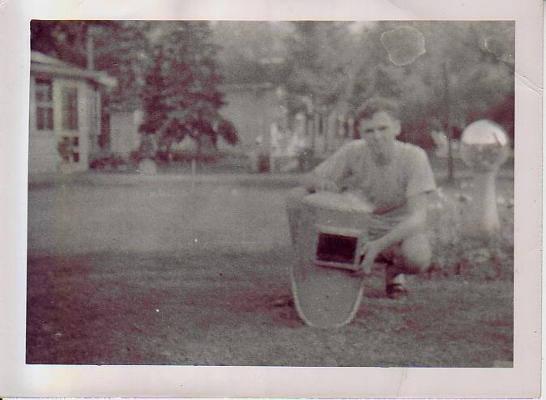

I never really told Mom about this “diving project”. Avon Lake was a small town, and nothing was a secret for very long. Somebody heard about our great diving project and told Mom a story about a boy in Vermilion that had dived, came up with blood running from his eyes and ears, quickly dying.

Bad beginning…

Mom was concerned that use of this helmet would certainly lead to a horrible death, and insisted that I “get that thing out of here”….

The diving helmet then went to Bob’s house and stayed until his mother saw it and, “get that thing out of here”..

So the helmet returned to Rosewood until it took a trip back to BobHallenburg’s.to “get that thing out of here”.

Back and forth,. Back and forth…

The helmet was never really water tested, but it did have a lot of land travel miles.

I spent a lot of time in our shop at school. The shop was well equipped, with the typical metal and wood lathes as well as arc and gas welding and cutting. For arc welding we had been cautioned, of course, to protect our eyes and skin. Unprotected skin could cause burning, similar to a sunburn. Aha!! Here was a way to get a “tan: even tho this was the winter season I went into the welding room, took off my shirt and proceeded to get my “sunburn”. Later in the day I saw Janis (my then girl friend) and lifted my shift to show my new “tan”

“what on earth did you do to your stomach?? It’s all red!!”

Somehow “red” stays red, and then blisters --no tanning done here

I recall working part of one summer at Nussdorfer’s farm at the S.E. corner of walker and center road (now called avon-belden). Pay was 12 ½ cents per hour and for a ten hour day total was $1.25 !! By today’s standards that figure is unbelievable; bear in mind, however, that I could then go to Lorain and buy three T shirts for only $1.00.

The farm work was an education….

Andy , in our apple-picking group, gave us our sex education lecture. He spoke with such authority—for example, babies came out from between a woman’s breast……

If a woman had large breasts that meant she “slept around”

One of my teachers (who will go unnamed, even tho I remember her) was a little on the stout side, and she did have large breasts. I’d sit in her class, staring at “those”, mesmerized, thinking “golly, when does that woman rest ??

I still had the morning Plain Dealer route when I bought my first car A 1923 Ford, called a Model T., at a price of $10.00 !! Four cylinders, sparked by four coil boxes and magneto. No battery, no starter, so it was started by hand-cranking
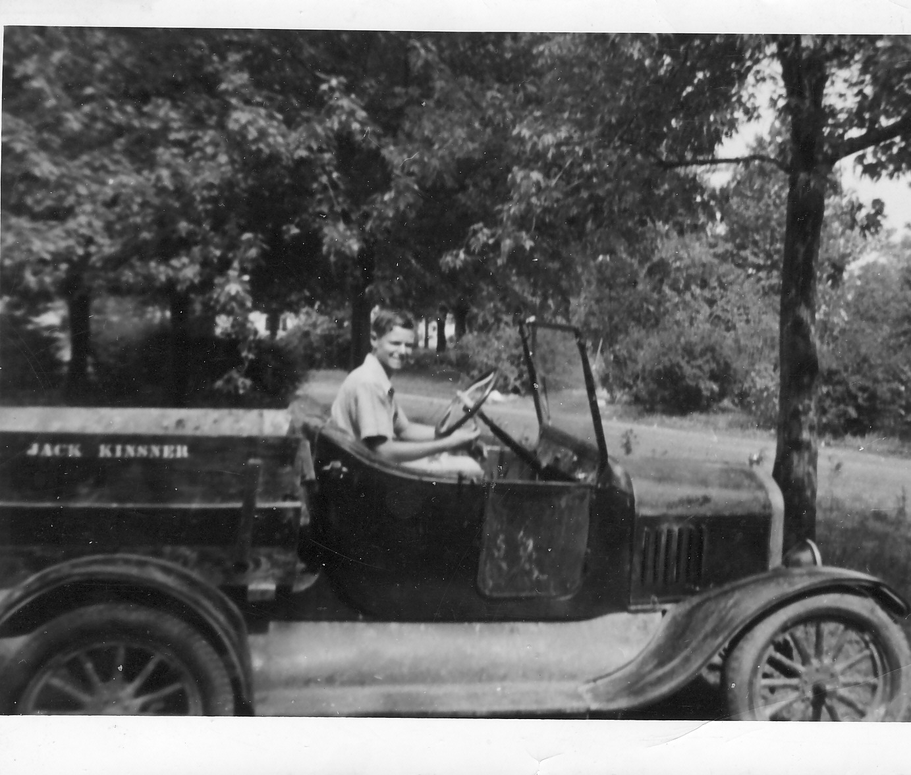

.

This was just so basic --
But it was my first car --
Look at the wheels--wooden
Spokes !!

Look!! What you see is what you get!!! No roof, windshield wiper was “hand powered” ----- only one door, on the passenger side.

The headlights were powered from the magneto: the faster you drove, the brighter the lights. Driving really fast would generate enough voltage to burn the lights out

This had been a roadster; I pulled the turtleback off, then added a box, called it a truck, and then hauled topsoil

The first load of topsoil was pretty costly. The weight of the dirt load pushed the fenders down on the rear tires, and ground off all the tire tread. On the next loads I’d put a block of wood between the axle and the springs -- this kept the fenders up and also made the steering very easy. The back load was so heavy the Ford front end raised.

Jim, my nine year old brother, was taught how to help me start the Ford. He would sit the front seat, was told that when the engine started (from my hand cranking) he was to advance the spark lever. He was not to advance the spark before the “start” or the crank handle would reverse and hit my wrist, causing PAIN. This was a learning experience –he never did learn when to advance the spark (causing wrist PAIN) but he did learn, by listening, lots of four-letter words……

Well, I moved up in the world and bo’t a Ford Model A from Bob Hallenburg.– price $15.00. ( I was still in the mowing business so I made a platform on the front of the Ford to carry the mower from job to job).I painted the Ford red, and put marking lights on each fender.

The Ford had doors, starter, and automatic spark. A rumble seat folded up from the rear, holding two more people So, here you are – a date car.—gal and guy in the rumble seat, me with my date, in a RED Ford with fender lights.!!

Cool

Another friend, Bill Kubach, had a model A also, and we took turns driving to school. Money to buy gas was scarce, but we did have our own private “supply”. Each Fall, Mr Kubach would put his Fordson (tractor) “up” for the winter—that included topping off the (big) gas tank. Well, you can guess what comes next---on those days when Bill’s dad was not around, we’d go to our closest “gas station” and siphon gas from the tractor.

Each Spring Mr Kubach would start the Fordson;after a few minutes the motor would die for lack of gas -- he’d scratch his chin , muttering “I swear I filled this tank last Fall…….”

There was a quarter mile cinder track behind the school. On occasion, at nite, Bill and I would circle that track in his or my car. We knew we could make three turns around the track until Ed Spaetzel (custodian, living across from the school) would come running around the corner, flashlight in hand. That was our sign to leave.

In a hurry…..

I passed some winter evenings in Bob Scott’s garage overhauling the Ford engine. New rings, grind valves and new spark plugs was called an overhaul job. I tightened the last bolt and turned the starter key – and—

Nothing.

I decided I needed a tow to start the car so I asked Dad to come and give me a tow. You could put the car in gear, and the tow will cause the engine to turn, and start. That engine was so tight the wheel locked all the way out the dirt drive to Lake Road. Dad stopped the tow, came back to me and said “this car will never start”. I asked for one more try on the road (cement road- good traction). We tried, and the car started

Next day I took it to school and asked Otto (the other custodian, who knew cars) about the loud banging and knocking coming from the “rebuilt” engine. Otto said “give it time, it’ll wear in”

It did.

Between my junior and senior year I had a summer job at Perry-Fay in Elyria. Les Urig, Bud Trigalet and I lied about our age to get the jobs. We were paid in cash, in a little brown envelope The extra money allowed the purchase of a ’34 Plymouth and also paid for “dates”

Lots of activity in my life at this time …I’d failed to notice that Mom was not well. I recall that we’d taken her to the Crile Hospital (now Cleveland Clinic) for an evaluation. Returning home she told of many conferences among the Doctors and interns regarding her condition. The diagnosis was bacterial endocarditic; at that time there was no cure.

Mom got weaker with each passing day, and we were unable to help, except try in our own clumsy way, to make her comfortable.

Stan and Grace (DeVille) began to visit several times each week,; looking back, I realize this was a support mission. Stan, of course, was now a well-recognized physician, and Grace had much experience as a nurse.

One bleak October evening, Stan, Grace, Dad, Jim and I were visiting in the kitchen. I left the table and went to the sunroom to check on Mom. I returned to the kitchen and told Stan Mom looked different.. He left us for the Sunroom and came back, quietly saying “she is gone”

We buried Mom at Elmhurst Cemetery in Avon and today Dad, Mildred, and Grandma Rice are interred there also.

My last year in school was busy—engaged in many activities, basketball, choir, band, orchestra and also working at Barnes Market, the local “grocery”.

Three nights a week, Chuck Beard and I would manage the store..

Barnes Market, at the corner of Moore and Lake, was a wondrous place!! We sold

Packaged coal

Gasoline, oil, anti freeze and kerosene

Telegrams, bus tickets, cigarettes, cigars

Produce, meats, canned goods, Kotex & newspapers, cookies

We also had a soda fountain !!!

Heat was generated by a large coal stove in the middle of the store

We also took orders over the phone, and we delivered each day.

Some of our more affluent customers ran a tab, and I remember Herb Barnes cautioning me to be especially considerate to certain folk, because they were “good customers” and ran a big tab ($40.00 per month).

My role was to wait on customers, and as the newest person on the payroll, I got to go outside and pump the gas, add, oil or anti freeze. I also cleaned the rest room (we had everything !!). After each one of these chores I had to wash my hands.

Our cookies were shown in large round cookie cans. These cans were 15” deep, and about 12” in diameter. The covers had a glass lid so one could see the cookies inside. One of our local characters was a man we called “Rookie: Rookie had been a conductor on the Lake Shore Electric Interurban, and when they quit running he started driving one of the new busses that replaced the streetcars, When he’d finished his shift, he’d deadhead back to Moore Road and his home.

Before going home, Rookie stopped in the store. He’d start sampling cookies all along the aisle way and when he’s tried them all we’d ask “well, which ones ARE YOU GOING TO BUY?”

“none, I’m not really hungry “

With my high school activities, and my propensity for being late, I would approach the store at a more than normal rate of speed. The parking was gravel, and I often stopped not soon enough and slid into the wooden building. A big BUMP, and cans would tumble from the shelves inside. Chuck would say, “ here comes Jack”

In the evenings Chuck Beard was the butcher. and I handled produce. Herb and Lola Barnes lived just behind the store and when they took an evening off, Bea Musal would baby-sit. Chuck then would “need to run an errand to Herbs house” The “errand” took some time, with Chuck and Bea visiting. The relationship ended in marriage. Chuck and Bea have been partners 58 years as of this writing.

As all of us grew older, strange things happened. We started to shave; we grew pimples and we learned that girls were more interesting than swimming in the lake. Avon Lake was still sort of a resort town and many Clevelanders had summer cottages here

In early June the Cleveland schools closed for the summer. The local guys looked forward to this because the “city girls” would be coming.
I began dating one of the “summer girls”, Janis Gladden. The dating continued until I enlisted in the Signal Corps. in 1942.

December 7th, 1941 will be remembered as Pearl Harbor Day – a sneak Japanese attack on our Pacific Fleet.

With my graduation in 1942 I went to work at the Ohio Tool Company, grinding machine gun bullet dies. This was a short-lived job. In December I enlisted in the Signal Corps Reserves and went to radio school. at E 79th and Hough. Classes were on a 24 hour schedule

In an effort to maintain some sort of “home” for Jim, I asked for the 11:00 p.m. to 7:00a.m. class time ( this was wartime-school twenty-four hours a day)). This had me home during day hours and Dad was home at night. Jim was never home alone.

The school was in the Thomas Edison School at 79th and Hough (east side of Cleveland).If I drove, I’d park in front of the school, and usually left my car unlocked thru the night. Things change with time—today the neighborhood is so gang-managed and run-down that I’d not even drive through there in the daylight.

The Cleveland schooling was promising and the Signal Corps sent me to Lexington Kentucky for advanced training. Classes were at Transylvania University. I learned a new language: Louisville was called Loovile by the natives, plus other strange twists to our best way of speaking.

We roomed, two to a room in a turn of the century brick house. My roommate was Bob Tishkoff. About every third week we’d go to Cleveland for the week-end. From Lexington to Cincinnati was a train system powered by steam locomotives painted green Segregation was in effect, and the station had separate rest rooms for “colored”.

Cincinnati to Cleveland was a ten hour ride through the night, and we slept in the day coach. At the end of the coaches was a bench seat. We learned that by folding the regular passenger seat back, and using the bench seat, we had a “bunk” about five feet long. Before the three of us boarded at Cincinnati, we’d flip to see who got the bench seat. The odds for me were 3 to 1 but it made no difference to me whichever one of the other two won the toss, they couldn’t sleep on that makeshift bunk. After about one hour of trying to get comfortable, they’d get up from the seat and,: “here Jack, you take it—you could sleep anywhere”.

And I could

After Kentucky I reported to Camp Crowder Missouri for Basic Training. We learned shooting, digging fox holes and hiding from the duty officer

Moving into active service was pretty typical. Six weeks training at Camp Crower Missouri, and then to Fort Monmouth New Jersey for more tech training.

My training there was for field communications (read battle), and carrier and repeater specialty.

Fort Monmouth was an hour’s train ride to New York City. I remember the great girls at the USO. They were caring and considerate, knowing that our next stop would be to join our buddies in Europe, digging fox holes and fighting Germans. Saturday nights in NY many of us went to a local church to sleep –there were hundreds of canvas cots and a free breakfast..

Time to go overseas was approaching, and our next assignment was Camp Reynolds near Sharon Pennsylvania. There I got myself a job as an orderly clerk.

Orderly Clerks keep records, issue passes, and assign the K.P. (kitchen work ) duties.

One of the guys in our company lived in Cleveland and had a car on the base. Eureka—I now had transportation to Cleveland !! I was the Orderly Clerk, so my friend never pulled KP and always had weekends free and a pass (a win win for both of us!!)

Camp Reynolds was lacking in basic amenities. Only a holding facility, the army called it P.O.M. –preparation for overseas movement. Wooden barracks smelling like unwashed underwear and smelly shoes, While “waiting”, we’d pass the time playing blackjack, visiting the PX, or bragging about our big night out. Big night out was either to Youngstown, or Sharon Pennsylvania.

One hot May afternoon word flashed thru our area, that there was a woman walking down the street, peering into each barracks! This was interesting ‘cause most of us were sitting around in our undershorts, or less.

I looked outside to view the commotion, and lo and behold, I recognized the woman…………….

My Aunt Sophie!!!!!

Aunt Sophie knew I was at Camp Reynolds, and she was determined to find me. As a County Nurse she must have had connections to have gotten past the MP’s at the gate. She took me back home to Meadville and fed me a wonderful dinner.

A few weeks passed, and finally we moved out, destined for overseas

The trip to Liverpool England; a on a Troop Ship was 14 days. We were on the SS G Washington, which had seen service in WW 1. With wooden decks and everybody smoking, the Captain was as much concerned about fire as a submarine attack.

At the beginning of the trip we watched our “protectors” man the machine guns, fore and aft. A small plane flying overhead, would drag a windsock, and the idea was to follow the target and shoot holes. It was less than reassuring that the gun crew missed completely. Their aim was so bad we were concerned for the welfare of the tow plane, only a few hundred yards ahead.

My time overseas was typical. Training at a replacement depot in England. I was sent to a hospital with an infection, and when I got out, all my buddies had been assigned, and were gone. The army had a shortage of truck drivers -- so with all our special communications training, some of our group ended up driving trucks.

Some weeks after the hospital stay I was sent to Pettypool England to join a newly formed Signal Base Maintenance Company. Leaving England we arrived in Paris one week after the Germans had left. The City was still blacked out and there were a few German snipers hanging around They didn’t stay long, and I don’t remember any serious shooting..

Somewhere along the way I received a “Dear John” letter from Janis, indicating she’d found “someone else”. Probably just as well, I was going to spend a lot of time overseas

My first assignment was supervising local Frenchmen repairing Spiral Four communications cable This cable came back from the war zone, cut up, torn, and generally trashed. We cleaned, spliced and tested the cable and returned it to battle area..

The workers were French, and I instructed them through an interpreter. As the weeks passed, it appeared that the interpreter was telling the workers how he thought the work should be done, not what I was telling them thru him.

We terminated the interpreter, and I began to learn the French language through the workers. My knowledge of the language also contributed greatly to my social skills with the local girls

Next was repairing carrier and repeater equipment. I was the only one with that spec, so I did that work alone.

Along this time the Battle of the Bulge was decimating our forces, and the medics rousted us for a “physical” the middle of the night. We all had a brief exam and in they “looked” in many places; one was a view of our feet. My flat feet kept me on the base; by mid-morning 20% of our company had gone east to the Bulge activity.

Early in my army career, after I’d enlisted, I tried to get in the Air Corps.. I was refused entry because of flat feet -- once again my feet had an influence on my army “career”

Moving up in responsibilities was easy, and after a series of assignments overseeing repair of war damaged communications equipment I was promoted to Depot Wire Chief.

Wire Chief was responsible for all depot communications, local and trunk lines.

We had a stockade to house the German Prisoners of War. We used them as laborers on the base, and at night they were returned to the stockade

When the Germans left the Signal Depot they had sabotaged a lot of the depot communications equipment. My role then, was to continue the rehab job that had been so well started by Corporal Harper..
The assignment wasn’t that difficult but I did get a P.W assigned to me. Kurt Denskat had been a German Officer and spoke perfect English. I guess of all the jobs assignments the PW’s had, working with me was the easiest. No hard labor, just venturing outside if we had a line fault somewhere

While I was Wire Chief, the European War ended.

The 3246th Signal Base Maintenance Company was disbanded, and we were sent to an airport in Villacoublay to await transport to the Pacific War

Passes to Paris were restricted to only 30 men for one evening, so in a Company of 215 men my odds of getting back to my favorite city were limited

However…………..

Most of my company were New York City boys, and did not know how to drive. Word was put out there was a need for men to drive the six by sixes to Paris for the “pass trips”

I could drive, and I could handle that assignment.

“Eureka I get to go to Paris, and since I’m driving, there’s no way they can leave without me”

So, with a load of G.I.,s I’m driving back to camp one evening. On the return trip I needed to climb a BIG Hill, which meant downshifting to a lower gear…………….

I didn’t know how to downshift …..

Only way to make that hill was to “floor” the truck on the downgrade, and get enuf speed to make the hill

Which I did.

I floored that sucker, that truck had never gone faster…….

Interesting –lots of chatter going on in the truck rear, but just before we got to the bottom of the hill at high speed, it got real quiet (Like they were all waiting to die)

We moved towards the top of the hill

Slower….

And slower…

I crested the hill at about 5 miles per hour

Next day I borrowed a truck and learned how to downshift. Thus began many “pass trips” to Paris.

The replacing unit at the Signal Depot was having operation difficulties, and we were sent back to the Depot, and me back to my job.

Then Japan surrendered

With Japan’s surrender, of course, there was a clamor to “get the boys home”

Back at the Signal Depot, or, was I worth a radio ….??

At the conflict’s end there was a lot of moving troops and personnel. One morning, at breakfast, one of my buddies remarked “…so, you’re going to Germany…”

This was news to me and he suggested I look at the posting on the Company Bulletin Board

I perused the bulletin board, and sure enough, there was my name, among others, to be transferred to Germany. I went immediately to Lt Jorgenson, my “boss” to complain.

“Jack, you’ll have it made. You’ll have good accommodations; find yourself a fraulien, and you’ll be glad you went…”

“but Sir, I like it here, and I don’t want to go”

“Okay, Jack, if that is what you really want, I’ll take care of it now. Sit down while I make a phone call”

He picked up the phone and called someone at Com Z (headquarters) There is some first name salutations and then: “Ray, do you still want a table radio?? Yes?? Ok, take Sgt Kinsner off the transfer orders for Germany..”

He hung up the phone, turned to me, smiling, and reassured said, “you’ll be cut off the orders this afternoon>>”

And….

I was.

In 1945 I was dating a girl named Raymonde Veber. She was very attractive, and spoke perfect English. We spent a lot of time together.

On one occasion she mentioned that she played tennis. I told her that I played also, and suggested we go to a local indoor court. Raymonde didn’t want to go. Over the weeks I persevered (called badgering) and she reluctantly agreed to go.

It was pretty embarrassing.

When she served, I never saw the ball. When I served, I never saw the return!!

Later I learned the year we were dating she was the French National Singles Champion. In that time we dated she never once mentioned her achievement.

Talk about modesty

At war’s end leaving the European theater for home, was based on a point system. Values were assigned to your time overseas, time in combat, married, married with kids, etc. To be eligible for quick return, one needed 85 points

My points were accumulated only on my time overseas and none of the other criteria. Projected time before I headed home was 4-6 months.

Not good.

There were some shortages of civilian people for key positions and these were being filled from qualified service personnel who could be discharged and then work for the War Department in a civilian capacity,

“O.K.If I can’t go home now, I’ll stay, but under better circumstances…”

Under certain conditions one could get released from the Army, and I’d found a way to do it:

There was a position of Wire Chief for American Graves Registration Command. For a qualified person this meant responsibility for AGRC communications for all of France and part of Belgium.

Prior to my interview for that job I was told that one person interviewed all applicants for every position that was open.

(Great, just go down and “snow” that recruiter…)

My interview with the recruiter went something like this..

“yes, I’m presently Wire Chief for Signal Depot S 891. I’ve a two position board, 42 local lines and 4 trunk lines. I can explain what that means……”

“not necessary Sergeant , in civilian life I was chief test man for AT&T in New York…”

(Sure Jack, just “snow ‘em)

In spite of my foot in mouth disease, I was awarded the position pending my discharge from the service .

After job acceptance, I needed to get my discharge from the army. I still remember walking to the table where a lieutenant sat, holding my discharge paper. I approached the table, arm out, reaching for my discharge.

The officer said “in this army we salute, sergeant” My rejoinder was “I’m getting out”

His answer “you’re not out yet”

So I saluted….

And I was out

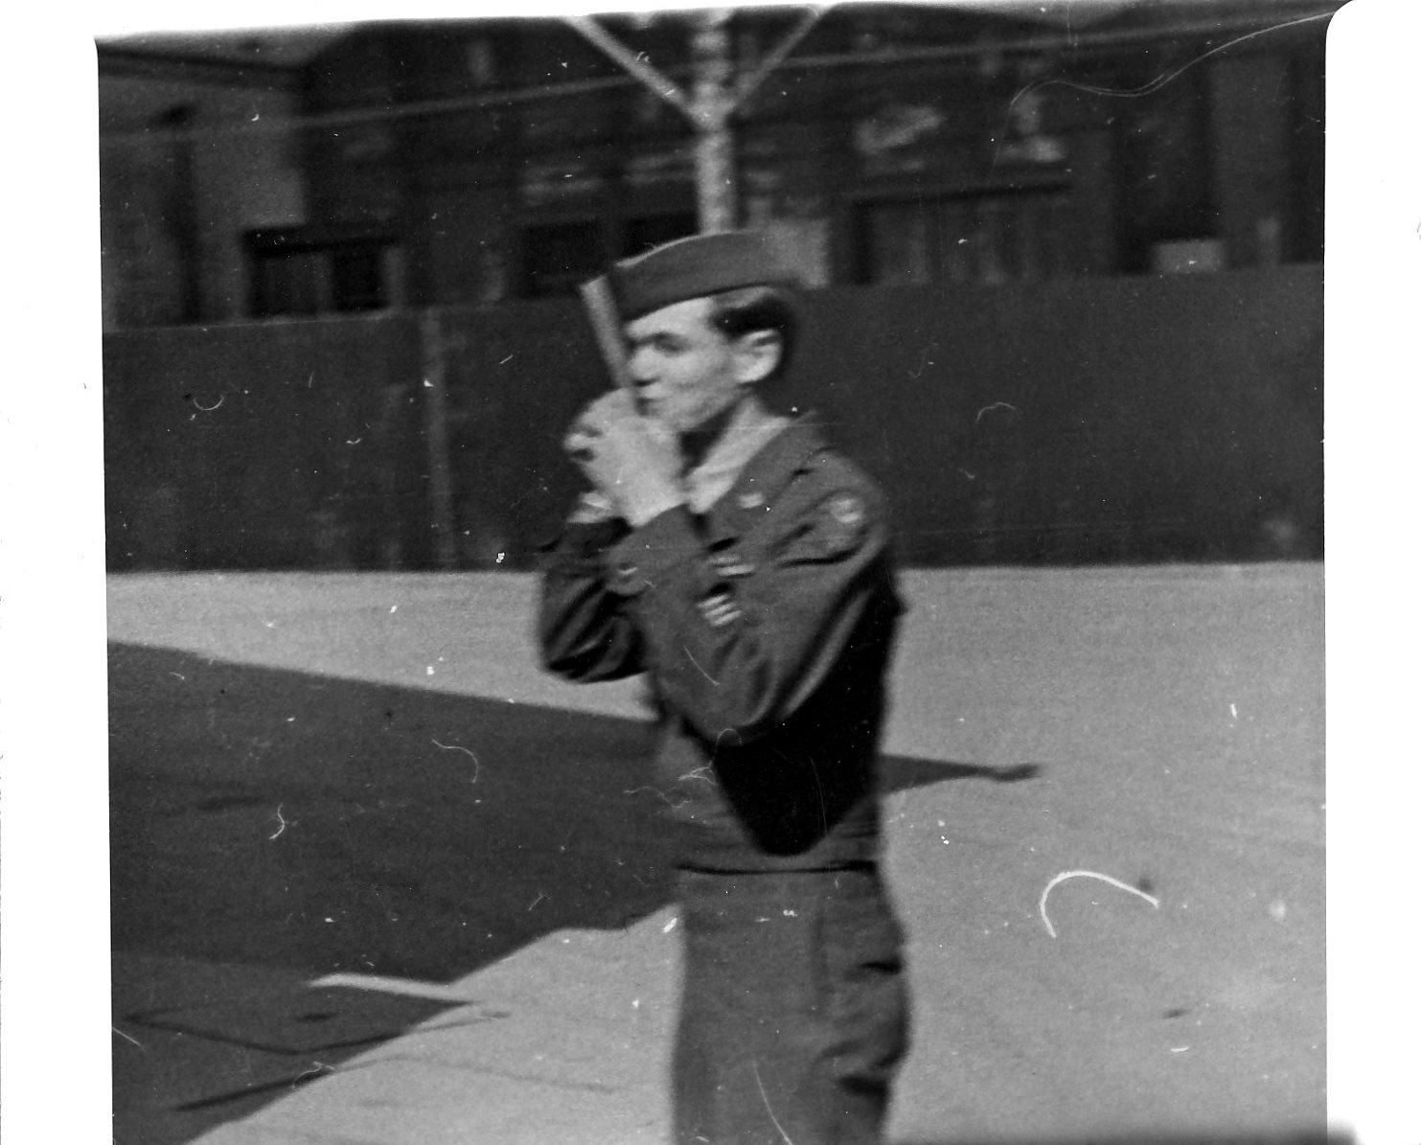

KISSING THE DISCHARGE PAPER 3/20/46

After this recognition of authority, and my salute, I got the coveted paper and took my discharge in March of ’46 in Paris, France. The desirable role as Wire Chief for AGRC was now mine!!.

I would be responsible for all of the phone communication equipment in France and part of Belgium. The outside lines were property of PTT, but line troubles and repair were our job.

I look back on that time, and wonder at my chutzpa. Supervising some indigenous personnel, and a gang of PW’s was awesome!!. At the time I didn’t realize the immensity of that position.

I arrived on the job in the middle of the relocation of the main switchboard project. We disconnected the old ‘board from a building in Versailles. We. then connected to a big new board at the Hotel Trianon, headquarters for the AGRC.(American Graves Registration Command )

I then worked with, and watched the German P.W.s doing all the wiring and transferring hundreds of lines without a service interruption. This had been well organized by Captain Hamilton and was a smooth operation

Interviewing female candidates as switchboard operators was not my province –that was handled by our Chief Operator

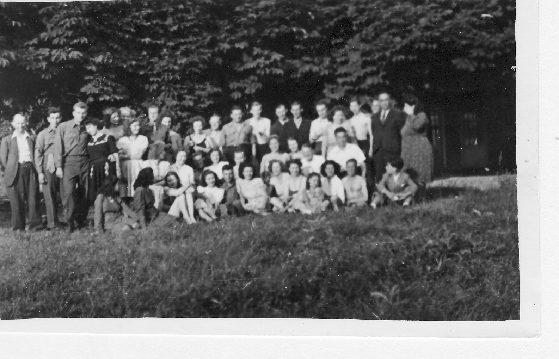

OUR CIVILIAN “CREW” Hotel Trianon, Versailles, June 1946

The photo above was my civilian group which included operators (the women), supply man, directory service, tt repair, and Chief Operator

My German P.W.’s did all wiring, switchboard and generator maintenance. They numbered about 15.

Now, with the great civilian status, I needed housing. I moved into a house with a couple of officers and a civilian, but with my addition, the “family” was getting crowded

One of our house group, Lt Zimmie had made a deal with Mme Dubonnet (of Dubonnet wine fame) to rent her house. The house had 4-5 bedrooms, a den, large DR, glassed-in spiral staircase and an in the ground pool. High on a hill in Gouches, we could see Paris in the distance. Known as “the city of light” the nighttime shimmering lights were awesome

The pool boasted a bathhouse, with showers. Empty when we moved in, we filled the pool using a garden hose. (see, not
everything was perfect, and there were some hardships)
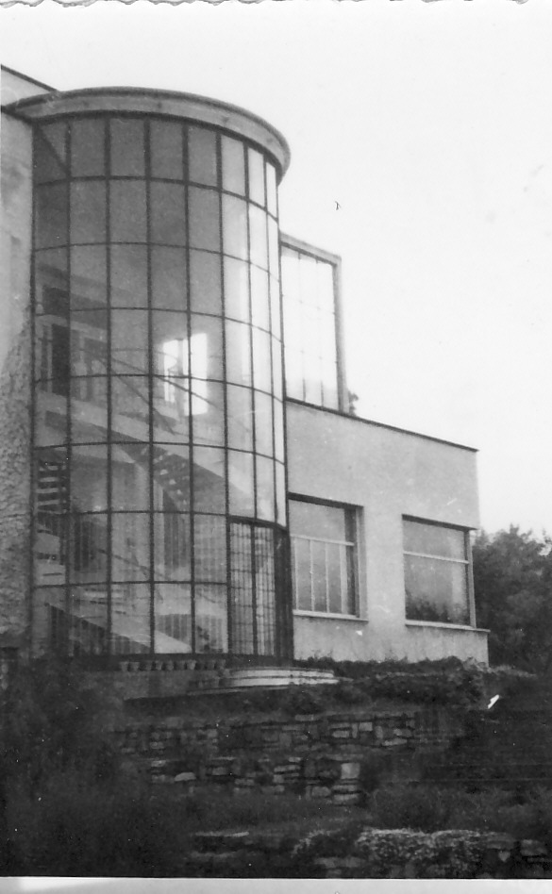

Note the beautiful glass enclosed rear staircase. From here one could see Paris in the distance. (My room was at the top of the stairs)

After getting a lease on the house, and moving in, we proceeded to “borrow” three German Prisoners of War from the stockade. We gave them quarters in the carriage house. Their jobs were cooking, sewing (yes, sewing) housekeeping and general maintenance.

Escape?? Heck no, we didn’t need any guards for those P.W’s; they had it good, and they knew it.

They weren’t going anywhere

We were some miles from the Hotel Trianon, (Graves Registration Headquarters where I worked) and getting a jeep and driver from the motor pool was an inconvenience. I went to the yard of army foreign liquidation and bought an army jeep for $200.00. I left the jeep at the Carriage House for the prisoners to work on. Their instructions were to clean it, paint it, and tune it up. With typical German attention to detail, they did a fine job. I had the best-looking jeep in the entire area!!

One of the prisoners was artististic and at my request, painted “Eight Ball” across the front. There is an old expression, that when things are not going right, one is “behind the eight ball”

I’ve no idea why I used that expression,’ cause things were, indeed, going very well.

The jeep was shipped back to the U.S.from Bremerhaven, Germany, so I needed to drive it there for export. That was no problem; I would be returning to the United States from there anyway.

On the way to Germany, a bearing went bad,. When I recovered the jeep stateside I purchased a new motor from Sears for $200.00.

While I was in South Bend, at A.T.& T.,brother Jim was using the Jeep for snow plowing, and “other things” See the pic below
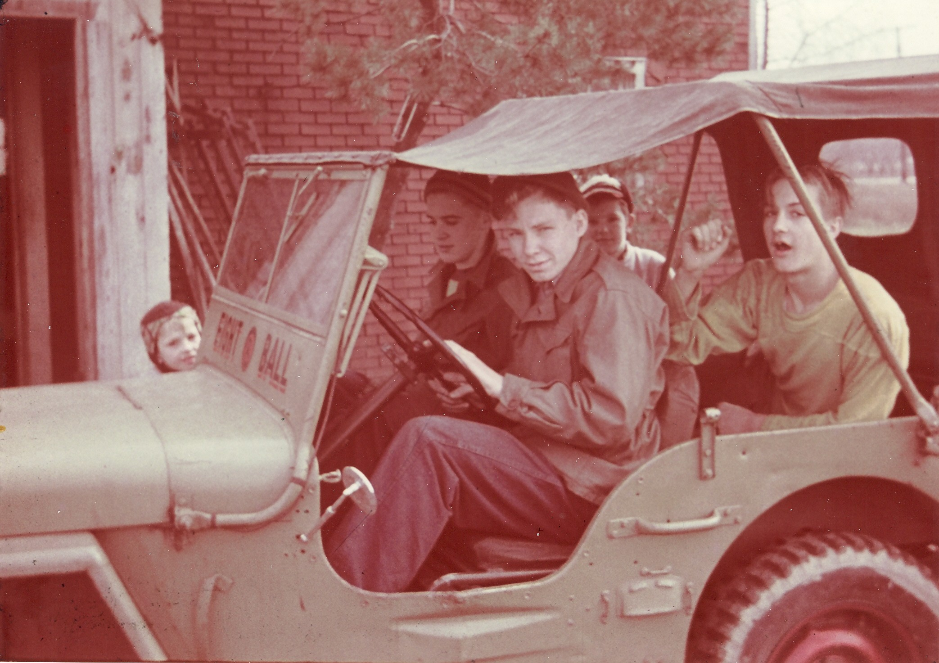

.

One of our “roomers” in our house was the officer in charge of the dining room facilities at the Trianon. We always had enough to eat.

We had gotten a film library and projector from Special Services, so with the pool, film library, good food and other amenities, life was good.

A great life, and I knew it.

All good things come to an end, sooner or later. My six month contract was extended to nine months, but it really was time to go…..

I returned from my overseas employment in November 1946. From the time I enlisted, until my return to United States had been four years.

So, back to civilian life..

All of my returned acquaintances were passing time at Spanicks Tavern, the local bar hangout. They’d spend hours drinking beer and telling stories about the “war”.

I had signed up for the 52-20 club to “enjoy” my return and unemployment. The 52-20 club was a government dole of $20 per week for 52 weeks until we G.I.’s “found ourselves” (i.e. employment)

Spanicks wasn’t my thing. I drifted for three weeks before seeking employment.

My first job interview was at National Tube In Lorain. (a steel mill) The City at that time was a beehive of activity. National Tube, Lorain Products, Thew Shovel, American Shipbuilding -- all heavy hitters. Lorain was a busy, prosperous town.

National Tube was my first stop They offered me a job, but the offer was not what I wanted. I told them my forte was communications; the reply was, “sign as labor and we’ll put you in communications when the opportunity comes up”

No way.

I then decided to go to American Telephone and Telegraph; but not thru “channels” Somehow I learned that a Mr Buffington was a Regional Manager for A.T. & T.. I arranged to see him at his house in Bay Village.

Mr Buffington had a nice home in Bay, and he treated me very kindly. We talked of my Signal Corps specialties, and I reminded him that we were “neighbors” – he in Bay, and me in Avon lake.

Sure

He probably felt sympathy for the vet who’d spent 2 ½ years of his life overseas Mr Buffington said he had nothing in the Cleveland area, but there was an opening in South Bend, Indiana

Compensation was discussed, and I was offered $32.00 per week. More discussion ensued and I reminded him of my vast (?) experience as Wire Chief for AGRC. My salary was then upped to the princely amount of $38.00.

I reported for work at 222 S Scott Street in South Bend, best known as home of Studebaker Automobiles, Singer Sewing machines, and Notre Dame.

Life takes some funny twists and turns.

When the folk in the AT&T Long Lines office learned that “Buffington sent me” the people thought that I had some sort of special “pull”

I was given a lot of “make work” projects and was getting pretty bored. My relief from boredom occurred when I was assigned to a traveling road crew doing crosstalk balancing for K Carrier

Our crew of five went from town to town balancing out inductance and capacitance on newly installed telephone cables. South Bend, Dowagiac, Kalamazoo and Michigan City were some of the towns I remember. The two supervisors drove Ford Sedans with a governor set at 55 mph. I drove the supply van with our test equipment -- that governor was set at 50 mph. Those vehicles had a manual choke. if I tweaked the choke just right, I could coax that van up to 55 and keep up with the bosses in the sedans

We stayed in hotels, and our move each three days did have drawbacks – our laundry never seemed to catch up to us. We ate out, and were allowed up to $7.00 per day for food. (remember, this was 1946, and $7.00 seemed to be sufficient)

At the end of our tour, we returned our vehicles to Cleveland and final expense reconciliation with the finance department. I still remember the clerk in finance telling Ted Willhoite (the team leader) “he’s got seven dollars written for every day he was on the road. Dies he eat that much?” Ted’s reply “yes, you should see that boy eat !!” I’ve always been blessed with a good appetite.

Back to South Bend plant and the same old boring job. One day I went to my section leader and said I’d like to know about “raises”

“Jack, every half year, you’ll get an automatic raise of six dollars, until you reach $52.00. then the automatic raises stop and you become eligible for management”

“What if I work hard; can I get a raise sooner/ “ I asked

“the raises are scheduled, Jack it’s part of the union contract”

“What if I loaf?”

“We would be unhappy with that, Jack, -- I’ve told you, the raises are part of the contract”

It was either that day, or the end of the week that I gave notice and quit.

Someone, very close to me, who’s advice I respected, told me that I was college material and that I was wasting my life at A.T. & T --another reason to quit, beside the pay program.

I enrolled at Ohio State that Fall

I had no direction, so I decided my major would be Electrical Engineering. My close friends Bill Foote and Bob Marimon were taking that elective, and it “seemed okay” to me

The E.E course at that time was a five year program. Five years equal fifteen quarters, and I decided to go straight through, which meant no summer vacation.

In addition to the G.I. Bill which bought books and paid tuition, I was in business, selling propane gas to trailer parks.

Mobile homes (trailers) cooked with propane, kept in 20# tanks. They were called 20# tanks because the propane, when pumped in the tanks as liquid, weighed 20# The tare (empty) weight was 18 pound, so a full tank weighed 38# I bought the gas wholesale for 6 cents per pound, sold it for ten, cents per pound plus a twenty cent service charge. A typical Saturday would net about $30.00

Remember that number; later on I’ll tell you my starting salary at Cutler-Hammer

Back to the school story:

At the end of the 6th consecutive quarter I was mentally worn out for several reasons, and flat-ass broke.

I withdrew from school

I applied for a full-time job at Curtiss-Wright in Columbus wiring Navy R4D’s. (known as C-47’s in civilian life) I’d check out a wiring harness from the tool crib, then wire, and make all connections, from the tail to the bulkhead, just aft of the pilot compartment..

The planes were stripped, and completely rebuilt. From the entry, they continually moved towards the big door, leading to the tarmac. The planes were moved at night, but the movement went on, and if we didn’t get the job done soon enough, we finished in the plane in the hot sun on the tarmac.

The job was satisfactory and helped me achieve the goal of getting money to back to school.

My friend, Carrol Hixson was also working at Curtiss Wright, and we shared the ride.

Carroll was dating Laurel at the time and we were to go to a nearby lake and meet her for a picnic. There I met her friend, Betty; she and I seemed to get along well, and so I phoned her for a date. Betty accepted, which began a series of Saturday night dates.

I was also dating other girl(s) on campus, but had them separated to different girls on different nights. Saturdays were always reserved for Betty.

Over a time Betty became more interesting, and one evening at her house in Youngstown I proposed. Betty and I became lifetime partners in June of 1951.

To this day we joke about my wedding outfit.. The suit was borrowed from my brother, the shirt from my future brother in law; the shoes (and under shorts) were mine.

Betty and I hoped for a quiet informal gathering with a few friends to tie the knot.

Not so…

Betty’s father and sister Helen planned an extravaganza with a big reception. Lots of people, and much money invested.
Betty’s and my, plans wee for a quiet wedding. Her father and sister Helen had other ideas, and there was a gigantic reception at the ballroom of the Ohio Hotel

Our honeymoon was a two day trip at Niagara Falls—not very original, but after the behemoth reception, it a was good to get away and just be with each other.

After the wedding and Betty’s graduation in ’51, I had one year of college left to go. During that final year Betty worked in the lab at a hospital in Columbus, and I schooled and worked my gas route.

Our first “home” was at Thomas Trailer Park in Worthington, six miles north of the campus. By today’s standards, the amenities were primitive. The trailer had only cold water; the shower and toilets were in a cinder block building across the street. Most of our trailer neighbors had been warring overseas in less than primitive conditions, so there was no complaining about trailer life.

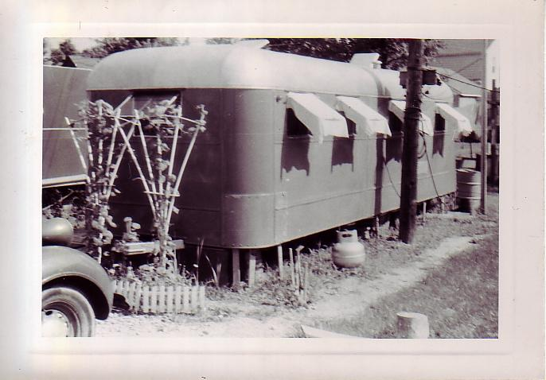

A HOT DAY (THE “AWNINGS WERE WET TOWELS)

Betty and I are both big people and the 27’ trailer, even for newlyweds was too “intimate. We searched and found a one-bedroom apartment close to the campus, and that was our home til graduation.

We shared the first floor with Arnold, his wife and daughter. Arnold was a radioman for TWA. The second floor was occupied by a single woman who had lots of men visitors at all ours of the day and night.

By May of ’52, I was in my second to last quarter, and Betty was five months pregnant. I had one more final to pass in my major, and I just skinned thru it.

Graduation, and-

So, off to the races!!

Seemed as though engineering graduates were in high demand, because everywhere I interviewed, I was offered a job. I remember those interviews to this day; Johnson Controls, A/C spark plug of GM, AT&T, Clark Control, National Tube, NGA and Cutler Hammer.

The interview with A.T.& T. was interesting: The recruiter read the list of my school activates which included:

Writing as a reporter for the Lantern (school paper)
President of IRE-IEE,
Editor of Current News (E.E. dept student newspaper)
Coordinator of E.E. D participation in Engineers Day
Membership in Theta Tau (engineering fraternity )

My point –hour was pretty low, and after perusing my activities report he remarked he understood why the grades were so disappointing..

The Cutler-Hammer interview was different: I’d signed up for an interview with Red Bolton. Mr Bolton was the Cincinnati area manager and I was to meet him on campus at an appointed time. The scheduled time came and went, and no Mr Bolton I left school and went to our apartment to do some painting.

After an hour I was really into the painting with the phone rang. Red Bolton was phoning to ask where I had been, and could I come now?? I told Him that I was in the middle of a paint project. Red’s reply was “come as you are”

So, forget all that BS about being clean shaven, suit pressed, shoes shined, and tie in place. I was paint all over, one big mess. The interview seemed to go well, anyway.

A few days later I got a phone call from Fred Wright, Cutler Hammer Sales manager. Could I come to Milwaukee for an interview??

The interview was productive, and Mr Wright offered me a job on the spot. George Jessup, a classmate from Ohio State was already there, so the decision was easy.

I felt most comfortable with Cutler-Hammer and so I started with them as a 2 year trainee in September of ’52. Salary was $307.00 per month (remember the $30.00/day when I sold propane??)

Betty and I rented half a duplex in the Town of Lake, outside Milwaukee. We were far out in the country no phone and no nearby public transportation. I still remember the nearby family that gave Betty support. The man’s name was Otzy, and his family were friendly and helpful to my new and pregnant wife. They also had a cow in the back yard.

I told you we were far out in the country.

Incredible ! A pregnant ,homesick wife, no phone, and no public transportation.

Betty and I have spent many Christmas’s together. but we remember fondly our second Christmas in Milwaukee. We went to a phone pay station, and Betty called home. There’s Betty , in the booth, crying, and visiting (definition: “visiting” means prolonged conversation). I’m outside, feeling badly for my homesick bride, and feeding her quarters for the phone.

That year we decorated the Christmas tree with greeting cards, tied on with ribbons. My gift to her was a grater, and a box of band-aids. Her present to me was a road atlas.

We’ve had 53 Christmases together since then and don’t much remember our gift exchanges. We do remember that one in Wisconsin, however.

Kathy, our first daughter, arrived in October ’52 – a fine healthy baby, and Betty enjoyed 10 days at a Milwaukee hospital “resting”.

With Kathy home, I decided that she was breathing too fast. A prompt phone call brought the county nurse to the scene, and later the next day, a call to the doctor. Both authorities pronounced the baby well; so, we had a healthy baby. I had also succeeded in aggravating the baby’s mother, by insisting on outside opinions

Looking thru some old papers recently, I saw the hospital bill for the ten days Betty was in the hospital after delivery. Total bill for ten days was $125.00!!!

Remember, though, my salary was $307/mo. So it was one-third of my income.

Everything is relative

The two year training period at Cutler-Hammer was short-lived. I was sitting in the bullpen at headquarters pricing resisters for outside sales staff inquiries, I remember sitting there and saying (in a rather loud voice) “I didn’t go to school five years to sit here and price these *#*#-- ! !.resistors!!

Two weeks after that tirade, I was transferred to Pittsburgh to work for O.P Robinson. Robbie was a great manager and good friend. He was a super salesman, and I learned many valuable selling tactics from him. I still have some of the old salesmen’s records; I almost always exceeded quota. I’m sure the results were because of Robbie’s excellent training.

Along about 1954, the government decided to build a nuclear power plant, the first in this country, at Shippingport, Pa. Specifications were sent out, and I worked up a quotation for the Unitrol** needed for this project. Jack Reed was a new salesman in our office, and I suggested he go for the public bid opening. Jokingly, I told Jack when they opened the bids, if we were low, he should stand up and demand an order. Luckily he knew I was kidding ‘cause we were low.

I was really excited that we’d play a role in the first nuclear plant in this country. First thing I did was review my estimate, looking for any errors.

There were none.

I had never been involved in construction for a Nuclear Plant so I constantly looked for reasons why I “had to” be at the site. A local lady found a bonanza when she discovered construction men would pay well for home-cooked food. On many occasions I had lunch with workers and enjoyed hearing conversations about the job progress.

There was not a lot of good short highway access to Shippingport , so another enterprising local operated a ferryboat across the river. The ferry was small, and I recall the capacity was four cars.

One day, while crossing the river we saw a deer swimming to the other side!!

Our portion of the project went well except for one small issue, requiring that I go into the plant to “trouble shoot”. Remember, this was only a few years after the war, and we were still paranoid about security. At the gate I had my camera in hand and the guard “borrowed it” until I would leave the plant

Two black suits met me at the gate, and put me in the back seat of a sedan; we went to a room with the malfunctioning equipment. I took out a pad and pencil to note the problem. Immediately they were looking over my shoulder to see what I sketching/writing.

Security

After finishing my work, and leaving the plant, the guard returned my camera.

“too bad you aren’t Japanese”, he said. “They were here last week for a plant tour, and they were loaded with cameras, and taking pictures.

So much for security……..

After several months working for Mr Robinson, I asked Robbie about my future in his office. We wanted to buy a home and “settle in’ Robbie’s answer was that he envisioned my assignment lasting a long time in that area.

With that reassurance, we decided to forget apartment living and buy a house.

Somehow, we ended up with Fred Neidhammer as our real estate agent. Fred was painter at PPG, and sold houses part-time. Like all good agents Fred asked about our “home shopping list’. We described our dream home, -- “ a setting on 1/4acre of flat, level land…..”.

Ha, Ha..(there is no flat land in Pittsburgh)

Fred showed many houses for us, but he was a terrible driver. We’d go down the road with Fred driving and pointing out the sights. Trouble was that as we looked at the sights, he did too. We decided to buy without too much “looking” We were afraid, with his driving, we’d get killed before we made a purchase.

After some tours, we settled on a brick colonial on a hill in Penn Township

We were the last house on the street and beyond the house was woods. We could look out our dining room window, and, in the distance, see the Allegheny River. Our heat was from a coal burning furnace, Our neighbors had gas heat. After a heavy snowfall we were very popular – the ashes from our furnace were great on the their icy driveways.

Our neighbors were Norm and Hazel May, with son Bob, and daughter, Judy. Norm’s employment was fixing pinball machines for folk upriver with questionable reputations. Hazel was s good mother, and Bob was a typical teenage boy. Judy was attractive, and her claim to fame was prom queen for her graduating class.

Of course, we were on a hillside, but I had a remedy. I’d heard of free dirt, haul yourself. I convinced Dick Averill, a neighbor, that we should partner and work together on Saturday to get fill dirt.

We needed a dump truck, and I arranged for one with a rental agency. Dick’s query was “can you drive a dump truck??”

“Sure, no problem”

As we drove down the street I’d push or pull levers so as to familiarize myself on the proper operation. We did notice, as we drove, that people would wave. I was proud of my driving ability so I’d wave back

Dick was not sharing my enthusiasm, feeling something was remiss

Remiss could be the operative word. Seems that one of the levers raised the dump, and as we progressed we were tearing telephone wires down.

We got our first load, and I noticed Dick was not really into the sprit of the project. After we dumped our first dirt load he decided he’d had enough dirt. ????

During our Pittsburgh assignment, our second daughter, Sue was born at McGee hospital on the July 4th. We had a choice of obstetricians, so we chose Df Baroni. Doctor Baroni delivered the Mellon Family babies. Our thinking was that if he was good enough for the Mellons, (multimillionaires) he’d be okay for the Kinsners.

Sue was born at McGee hospital on the Fourth of July. Luckily there wasn’t too much traffic ‘cause with each pain for Betty I increased my speed to the hospital by 10 miles per hour.

There was no wait time for Betty. She gave birth, and they did the shaving and other required things later.

As a Fourth of July baby, the nation has a holiday just to recognize her birthday….

When I first interviewed at Cutler-Hammer, I requested a Youngstown location. That was home for Betty, and I thought we’d be comfortable there. At the time of the request, there was no opening in Youngstown

In 1957 Youngstown vacancy opened and I was sent to be a part of a two man office.

Betty was pleased, ‘cause this move would take us back with family.

The years 1957 to 1962 in Youngstown were the most unhappy years of my life. I was out of my element calling on steel mills. My accounts were steel mills and O.E.M.s. The mills were hot, dangerous and dirty. Seemed the Ore Bridges broke down in the winter; the ladle Cranes broke down in Summer. At that time, in as well as selling, we were also trouble-shooters.. In additions to the hot, dirty steel mill environment, the local O.E.M.’s had never been “good accounts” for Cuter Hammer

The highlight of my five year sentence there was securing an order for a complete tin line at Granite City Steel in St Louis. This order was from Wean Engineering in Warren.. It was a complete line, we purchased the motors, did the engineering, and supplied the control.

This was the first order ever that Cutler Hammer had gotten from this G.E oriented company

The Youngstown assignment was not my idea of a satisfactory career. The day after we buried Betty’s Dad, she said “well, there’s nothing keeping me here in Youngstown now”

The next day I was at Regional Headquarters in Cleveland asking to be considered for a then-open position in Cleveland.

I easily got the transfer I requested and passed the first year in Cleveland going back to Youngstown midweek and weekends to be with family. The Youngstown real estate market was slow, and we couldn’t sell the house; Betty and family stayed behind while I worked in Cleveland.

This continued for 12 months.

During that time, the hot water tank broke, Sue got her leg wrapped up in her bike spokes and other dreary things when the “man of the house’” was elsewhere “having fun”

The first year in Cleveland was a semi-commute sort of arrangement. I’d leave Youngstown early Monday morning. Back to Youngstown from Cleveland on Thursday evening. Friday morning Betty would take me to the train and I’d be in Cleveland office at 9:00. I’d chosen Friday as my “in office” day. Betty had use of our one car all day, and I’d take the 5:30 train back to be met at the station by betty, Sue, and Kathy. At that time there was no buy-out transfer program so I commuted.

Cutlet-Hammer was not happy with the commute arrangement and that made two of us. They decided to guarantee the sale of our house. and we left Youngstown in August of 1963.

To facilitate the transfer, the Company agreed to pay all costs of taxes and maintenance of the empty house, and loan me money to buy a new one

We told our Avon Lake Realtor our price range, and that we preferred a colonial style house. In 1962 the population of Avon lake was about 4500, and there weren’t many houses for sale. After several days of looking we settled on a brick ranch on Duff Drive. The entire first block of this street were all brick, built by the same contractor, Al Curtis. Al, after building the street, lived on Duff; we decided if he lived where he built, he must do a pretty good job of building

So, we are settled, and the empty house in Youngstown is still unsold. After 10 months we finally got an offer. Mike Brice, in Milwaukee Headquarters, in addition to being a department manager, was also saddled with this Real Estate transaction. Mike’s discipline was engineering, and he had no experience or interest in selling houses.

With this first offer, Mike inquired about the market for houses in Youngstown. I told him the market was terrible and he said sell the ##!!-*&!! house (his words).

As of this writing, Duff has been home for the last 43 years…We have the same neighbors, the Tomaneks and Sezbinskies, and are blessed with fine people In reality, our house was small for a wife, three girls and a dog,

In 1996 we added a large family room -- almost all windows – to let the “outside” in. It’s odd that with the family gone, we added more space. Truth is, we couldn’t afford the expansion any earlier.

In 1958 I had been with Cutler-Hammer for six years. Altho we numbered 12000 employees worldwide, it still felt like a family type company.

Brother Jim was looking forward to graduation and employment as an industrial engineer. Early on suggested that he join Cutler-Hammer. Jim inferred that we were a small company, and he wanted to go “big” like a Dow, or GM.

The job market was slow and Jim phoned and asked if I could get him a job interview with cutler Hammer. I asked what happened with the Dow’s or GM’s, and he said they weren’t interviewing.

Not knowing exactly who to call, I phoned Ed Fitzgerald, the president of the Company. I asked Ed about a job opening for my brother and there was a perceptible pause at the other end of the line. Ed’s reply (and I’ll remember it for 100 years. ). “ I don’t know—one Kinsner is about all I can stand in this company”. Jim, of course, got immediate employment, and he was a great asset toCutler-.

In 1962 Betty announced she was pregnant. I figured I’d be retired when this latest child was still in college. The pregnancy came as no complete surprise; every nite at prayer time, Sue would ask God for a baby sister.

Lisa was born at Lakewood Hospital in April of ’65. The hospital staff suggested that we have the new arrival checked out by a pediatrician. Our reply was “no thanks” this is our third child, and we know all about babies.

Lucky for us one of the nurses decided that Lisa’s color was not good, and called the pediatrician. It was determined that she had AB incompatibility. She was completely transfused. at the hospital. Our church Pastor Stein came immediately and she was baptized.

Lisa’s sisters doted on her, and in spite of that she grew up to be unspoiled and very caring and compassionate for others. The same trait shown by her Mom and siblings Now, each day she stops home to see how mom and dad are doing….

Over the years, Betty has been active in PTA, raising kids and doing meals on wheels. That program entails packing lunches at the Sheffield Center and then delivering on a regular route to shut-ins. Meals on Wheels has been a career; she is now in her 38th consecutive year, She has been a good, caring mother and revered by our three daughters.

At the time Betty announced her third pregnancy I decided that I could not support a non-working wife, three children, partially support a stepmother (with Jim’s help), and finance college educations on one income. I decided to sell real estate part-time.

Selling real-estate evenings and weekends was a great opportunity for me. Our life style was better, and we paid for three college educations – our girls graduated with no college debt.

More about the real-estate later.

I’ll not bore you with the life history of a Cutler-Hammer Salesman, but I will recount the results of a sales Contest in 1978-79

In 1978 I was lucky enough to generate enough business to win (watch this):

Two television sets
A Toro lawnmower
A Tappen Cookstove
A Dewalt radial arm saw.
Two week-end trips and lodging
A set of towels
A two door refrigerator ( I gave this to my inside man)

added incentives were trips overseas for husband and wife which I won

A trip to London in ‘78
A trip to Spain in 79
A week boat trip down the Rhine River in ‘80

Trip for ’81 was to be a trip to Hong-Kong. Bill Worcester, the Area Manager told me that no matter what I did in sales I could not have that trip – I’d had enough and the other salesmen were getting unhappy about not winning

just try harder fellows………………

No problem, I wasn’t keen on Hong-Kong anyway

My favorite account was American Shipbuilding in Lorain. Every boat built there between 1970 and 1979 had Cutler Hammer Control. Steinbrenner closed that yard in ’80 and took the work to the Tampa Yard. I’d made some good friends there and felt badly when they left.

The year 1978 offered a stock buying war between an Italian Company and Eaton Corporation. They both wanted Cutler-Hammer, and the stock rose from 19 to 38 dollars until the stock market suspended trading for this company. I sold my few holdings at a profit, but my friend and mentor, Bill Worcester (Cutler-Hammer Regional manger), was gong to hold out. Bill said “maybe the takeover won’t happen”

My rejoinder “you’ve got to be kidding !!”

O course, Eaton won, and brother Jim and I had new “bosses”

The years from 1970 thru 1980 were prolific years for me…seems as tho people kept wanting to give me purchase orders, and I was constantly exceeding quota. I’d been doing the “same thing” for 25 years, however, and I was getting bored. with business. The only retaining incentive was the good customer relations. The “customers” wee becoming. more than customers, but good friends. Football games, chartered fishing trips, taking customers on plant visitations, and on the expense account did a lot to break the monotony .

The bonus’ were good too.

My luck promoting ship business convinced me that Cutler-Hammer should make a new category called Great Lakes Marine Specialist. Of course, I was to become that “specialist”.. I broached this idea to Bill Worcester and he suggested I do a survey of business possibility and then write a report to submit to headquarters.

Steve Whitley was a new employee, and had been assigned to be my shadow for six months. Steve’s help was invaluable, with me writing the report and Steve doing all the photo work and collating.

The report was completed, and the inch thick document was circulated (I don’t know to whom, if anyone) around headquarters for some weeks. Finally, from “on high” came the request to Bill Worcester that he release me to tour some offices demonstrating our new marine type motor starters.

Bill told me this was not a job advancement, and discouraged me fro the assignment, and I declined

One day, in 1982 Bill called me to the office and told me that as of that day, I was to be the new area manager.

Surprise, surprise…..

The area comprised 2/3 the state of Ohio, and managing the Cleveland and Columbus offices. for the sale of standard products
In addition to the title, I got a new private office, a bigger company car, and my own secretary/.

A promotion just in time to endure the big recession of ‘82

People speak of a “baptism of fire..”

In my twenty months as manager, I was obliged to terminate two salesmen, two secretaries, and close the Columbus office

Two men in my Cleveland office were transferred out,; my span of control was greatly reduced, and the manager job in Cleveland was eliminated

In view of the economy, Eaton decided that I was of more value selling than managing

So, back out in the field , but I kept the private office and the larger car. I was back on quota, and the accompanying bonus. so, I was making more money than managing, less responsibility and much more fun

A bruised ego, but I quickly recovered..

On the home front, things were going well:

Kathy had an interesting job as producer for Reading Rainbow, Sue was engineering successful blood drives for the Red Cross, and Lisa had started college at Ohio State

We were all healthy, a loving family unit, and things were going smoothly.

Lisa was still in college when I decided I’d had enough of Cutler-Hammer/Eaton, and decided to retire at the age of 63 The best I could negotiate was six months pay, and bonus so I left in June of ’86, and was paid thru the end of the year. Too bad,,,Cutler-Hammer was fun, but Eaton never cut it for me.

Jim Milner, president of Milner Electric heard I was leaving Eaton and sent Mike Puskar, his son-in-law to our house to recruit. I knew Mike would replace Jim on retirement, and Mike would be the new manager, so I accepted.. Mike gave me some established accounts, so I worked those about a day a week. This was a brand-new career -- learned about wire, cable, conduit, panelboards, fittings, and the other myriad of devices electrical wholesalers stock. I learned also that Distributor salesmen were talented, and knowledgeable for many, many products

After eighteen months I left Milner and began real estate full time…

Lisa graduated from Ohio State in 1987 with a degree in Fashion Merchandising. After a short stint at May Company Lisa went to the Gap at Westgate mall. Several months later she was promoted to manager, winning several sales contests. At closing Lisa would empty the receipts into a canvas bag and then walked alone, carrying the money bag, to a deposit box. God watched over her, because she was an easy target for any drug addicted mugger (of which we seem to have many) Quite often Steve would come to meet her for these walks.

The scene changes to Athens, Ohio: Sue and Don have parted ways and shared raising Jack and the twins, Pat and Rob. This story strains the imagination. Sue and Don are living apart, and separated, by court edit., not by actions They cared for the boys with complete cooperation and understanding for over ten years until they finally got an amicable divorce. They wrote the divorce with the assistance of a friendly attorney – on signing day, Don had gotten eye drops and could not read the decree.—

“what does it say, Sue?”, asks Don

“It’s okay Don, just sign it”

“O.K. Sue” (he signs, not really knowing the exact contents of the decree)

Sue and Don now have new mates and the four of them are best friends.

Go figure…

Kathy, by that time, is busy as a television producer for Reading Rainbow in New York. She traveled this country from east to west and to the south. Her work was recognized on several occasions, including three separate Emmy awards !! Also, some awards from the Catholic Diocese for a documentary she made on adoption.

While all this is going on, Sue is busy in Athens. She is a “single parent” maintaining a household, raising three boys, and working for the Red Cross. In the middle of all this, she decided to get into politics!! Sue campaigned for county commissioner, and she did not win. For this we were thankful Sue is too straightforward and trusting to be successful in that competitive arena..

During this period, I’m active in my second career, Real Estate.
With good referrals, my business was picking up, and Betty decided to help. Betty’s thinking was with her help, I’d be able to spend less time selling, and more time at home.

Betty studied for her license, passed and then became a full-time Realtor in our Avon Lake Office. Pete Corrigan told her she could “share a desk” with someone. “no way” she replied –she wanted her own desk

And got it

Betty and I worked well as a team, and at times were among the group of high producers in the office. When she turned 65, she retired, deciding that the business was too stressful..

Betty was knowledgeable, hard-working and honest; her departure was a loss to the Realtor community

Some “lake” stories

Rescuing a fish stringer: or, how to get fish without wetting a line

Jim Banjoff and I were out about a mile, getting ready to drop anchor and do some perch fishing.

Suddenly, Jim shouted “look at that –a boat sunk, and they’re in the water. They need help!!”

Yes, there they were, four bodies thrashing about in the water.

Even tho there was no way we could get four men in he boat, we did have extra life jackets, so we made for survivors, about a half mile
towards shore..

Altho our 14’ boat was overpowered with an 18 HP outboard, it seemed as tho we would not arrive in time to help.

We kept on course, but in the meantime a cruiser had witnessed the accident and had arrive on the scene, rescuing the four men from the water. The rescue scene was a mess –tackle boxes floating, some rods still in view, coolers, lunch boxes in sight, and -- surprise

The gunwales of the sunken boat 11

Somehow, the boat had sunk to the gunnels, and a line was being made fast from that boat to the cruiser, getting ready for a tow.

So, we circled the mess, retrieving the flotsam and passing it to the survivors on the cruiser.

Seems that the four were overloaded in a small, 12’ boat; a much larger boat had speeded past, and the wake swamped them.

Although shaken, no one was hurt, and we watched them being slowly towed away, in the distance

“Look”, Jim remarked, “”what’s that still floating??”

Just visible in the water was the boater’s fish stringer I piloted to the floating stringer and Jim pulled it in the boat.

“Jack, it’s full of walleye”

“Are they alive??”

“Very much so”, Jim replied

“Okay, we’ve got our catch, let’s go home”

STUCK IN THE MUID:

Just east of the Ohio Edison Plant in Lorain there are four boat ramps, maintained by the Polish Fisherman’s Club. These ramps access the large harbor, protected by giant breakwalls, some distance out.

After an afternoon of fishing we were coming back to the ramps and noticed three people wrestling with something in the water.

Closer approach indicated these folk were trying to right a sailboat that had somehow tipped over.

Pulling alongside we asked it we could be of help.

“No, they could manage” – somehow the top of the sailboat mast was stuck in the muddy bottom., because the boat was upturned.

There was no cause for alarm, although struggling, they seemed to know what they were doing.

We had extras lifejackets on board, and gave them to the three boaters, then headed for shore

We waited, and 30 minutes later they came ashore, returning the jackets. They proffered many thanks, remarking that they had been exhausted, and the jackets helped them float as they worked to right the boat.

THE FAMILY BOAT TRIP

My very first boat was a 16 foot Larson that I’d purchased from Jim Milner.

Jim was owner and president of Milner Electric, one of my biggest accounts. One day at lunch, I was giving Jim my very powerful “stocking spiel”: encouraging Jim, as a Cutler Hammer Distributor, to increase his inventory. We are in the Burke Lakefront Restaurant, and as I talked Jim was absent-mindedly watching the boats in the harbor.

Turing to me, Jim asks: “do you have a boat?” (so much for my attention-grabbing motivational sales talk)

“No, Jim, I don’t, but I’d like one someday”

“Jack, I’ll sell you mine for $300.00 if you promise not to resell it for two years”

Incredible!! A boat, motor and trailer, and he says “pick it up and pay me when you have the money.

The first summer I owned the boat was marked by my decision to share my boat fun with a family boat trip. With my announcement that we’d go out as a family, I detected some grumbling and muttering –“do we really have to go …?”

Not to be deterred, I told Betty to pack some lunch, and the family set off from Romps dock in the Vermilion river.

Not ten yards from shore Kathy yelled “go back, go back !!” Seems she’d left her radio on the back window ledge in the car, and she was convinced that it would be “baked”.

So, we went back, retrieved the radio, and then proceeded upriver to view the “scenery”

I did notice a buoy midriver, and a man, riverside, waving. Some questions from my crew about the buoy, and I replied that I knew about those things, and it was a Nun buoy.

Suddenly, without notice, the boat abruptly stopped, with all of us pitching forward.

We’d run aground; this, prompting comments from Betty asking “how did this happen,, I thought you took a boating courser!!”

No Problem.

Ever in command, I asked Kathy to stand on the sand bar (on which we were stuck) and push us off. The push off was successful, and we drifted away.

So, we were off the sand bar, and drifting away, propelled by the river current.

But.

Kathy was stranded on the sandbar in the middle of the river!!

Lisa, then six, began crying “my sister’s going to drown..”!!

Kathy, a good swimmer, swam back to the boat –we hoisted her up, I powered up, and I headed for The Lagoons

The Lagoons are surrounded by expensive homes, each with its own private dock. A good setting for lunch, and I instructed Betty to unpack our lunch

“I’m not sitting here in this area drinking warm pop and eating peanut butter sandwiches” complained Betty.

So, I moved out to the lake and dropped anchor.

With the grousing about the family trip, the return for the radio, the sandbar incident, and now the relocation. I was getting just a little pissed

Now, Betty complains “I’m hot”

My next maneuver, to satisfy this bitchy crew, was to pull the top up for sun protection.

At last, we’re settled’ I have

Gone back for the radio

Got stuck on a sandbar

Relocated from The Lagoon

Put the top up

Now let’s eat !!

Betty says “I’m getting seasick…”

I hoisted the anchor, powered up, and headed BACK TO SHORE

As we docked I announced in a loud voice to my family and all within earshot

“I will never, ever, take this family out in this boat again

I heard not one dissent

We’ve lived in the same brick ranch in Avon Lake since 1963. The house was never really big enough for two adults, three children and one dog. -------

In 1997, after the dog died, and the children left, I decided to add on the house for more room. I made structural drawings and specifications and put these out for bid.

Although not the lowest price, Paul Sedar seemed to have the best proposal. I still remember picking him up at one of his jobs and taking him to lunch. During lunch I told him if we didn’t reach an agreement he could walk back to the jobsite. We made an agreement and he got a ride back.

Part of our agreement was that I would do the wiring of the family room. Kenny Kropf was an good friend and a great electrician and he volunteered to help me when the time came.

“The time came”, and Kenny had his arm in a sling. We seated him in a chair, and from there he issued instructions as I did wiring

When Ken came for work the next day we had a special chair, and across the back was a large word printed BOSS.

We were always lucky to have friends that were outstanding tradesmen. Through some negotiating I’d been able to get an excellent buy on a new Carrier Heating and Air Conditioning System
Rob Melbar, another old friend, did the installation – a beautiful example of workmanship.

Some more history--

During the time we lived on Rosewood I kept notes in a five year log.
Looking back, I found this entry:

June 10, 1939

“…about 10:30 we heard cries of help! Going down to the lake, we got two fellows, but the third one drowned. Their boat got swamped when the storm came up….”

June 11, 1939

“…got to bed at 2:45 this a.m…”

We lived near the lake, and we spent time on the lake – we knew -- if the weather threatens, “haul ass for home”.

Back to the family:

Our girls have always been competitive---

After 9 years managing the Westgate Gap store, Lisa decided she wanted a change of career. She left the Gap, and accepted a job with the YMCA, serving as liaison with headquarters and the branches.

The YMCA job was not at all satisfying, and she gave notice

At our evening dinner table there was always a review of the day’s activities—what happened in school, on the job, at home during the day…..Lisa had heard lots about Real Estate and decided on this for her new career. She successfully passed all the entrance requirements, and now, ten years later she continues to be one of the office top producers, and seems to enjoy the challenges.

Sue has left her job at Head Start and is now working for the State training and placing unemployed.. Placing unemployed in Athens Ohio is a gigantic challenge. Athens and environs had been a coal area for many years. Coal fro that area has a high Sulpher content. High Sulpher content coal causes poor emissions from power plants and is not in demand. The mines have closed. Only other opportunity for stable employment is Ohio University. Opportunities are few at that location

Kathy, our television lady, at the end of Reading Rainbow, passed over one year consulting. a frustrating career. Word from New York during those trying months was that it was income--either feast or famine She then moved from that job to that of secretary to _Peter Straub the author, while still maintaining her contacts.

In 2004 she was contacted by Roads To Success for an interview. The interview was fruitful, and she is still in New York as

Betty continues as driver for Meals on wheels, and this is her 37th year. Every Tuesday morning she and Eadie Sezsbinski go to Sheffield Community Center to pick up 18 meals. They then deliver tto those in Avon who are either infirm or aged, or both.

Through the efforts of Lisa, we maintain our membership in the Westlake YMCA, and work out three days a week. “Work out” means brisk walks on the track, and using the machines to strengthen the shoulder, arm and leg muscles.

Betty and I have membership in the Irish Heritage Club, and the American Legion. Our activity there is limited to parties and dinners….

As I write this in November of 2007, I’ve retired from Real Estate, and I’m finding lots of time on my hands. I’m spending time in my basement shop which is equipped with every tool imaginable. Now, with more spare time, I’m becoming more active in Kiwanis, and I’m also a member of the Board.

In August (’07) Sara and Jack (our grandson) brought our first great grandson, Tanner, into the world.

Our family vacation in September at Kill Devil Hills offered our first look at this handsome healthy four week old baby. What a treat !!
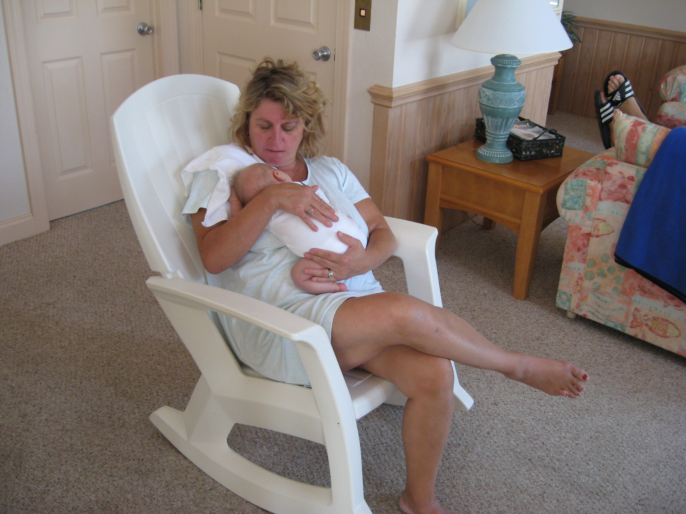

Grandma Sue lovin’
That child to pieces

Kill Devil Hills 9/10/07
,.

Our children are well and successful in their careers.

We have been blessed.

Jack Kinsner April, 2004

OF INTEREST-------

One year the Lutheran Church was really pressed for money

The Church was behind on mortgage payments, Columbia (Gas) was threatening a shutoff, and we were behind in our obligations to Pastor and Staff

Desperation prompts desperate measures and we were desperate

The Board decided to sell “notes” in $25.00 increments. “Buy notes now, and in 12 months you can redeem the notes at principal plus interest”

This was sort of a Religious Ponzi Scheme, but we sallied forth on this (illegal) mission of selling notes to earn income
Sure…….

During that 12 month “earning” period I bought a used power lawnmower from Bill Worcester for $67.00

I picked up the mower at Bills, and paid him:

With two $25.00 notes and $17.00 in cash!!!

Bill ..”what are these????”

Jack “these are like money --I’m paying you now, and in 12 month
You’ll get $50.00 plus interest”

Bill never redeemed the notes, so in essence, he sold the mower for $17.00!!

In retrospect, it was worth more than $17.00, but the sale did help Bill empty his garage.

OF INTEREST, PART TWO

Our middle daughter, Sue, decided she just had to take guitar lessons…..

The intense guitar affair lasted a whole eight weeks….
Another eight weeks listening to reasons why she was just too busy to think abut the guitar

We got the message

Time to sell the guitar

At that time the best vehicle to carry a message to the public was the Cleveland Plain Dealer Classifieds

So, I ran the ad, giving my office phone number; to phone Avon Lake would have been a toll call.

The ad was productive, and I arranged to meet a buyer in our office conference room the next day. I’d bring the guitar

That day my prospect showed, and so we sat in the conference room with him strumming the guitar as I saw Bill Worcester pass the open door !!

Following day, Bill and I were discussing a forthcoming exhibition
he interrupted the discussion with

“by the way, are we running a music store here?…”

SEQUEL (as of Sept 11 2016)

Fifteen years ago, today, the event that changed the lives of all living in this country ….

I sit here At noon, reminiscing about our country and its changes……

My life, and changes……….

.

