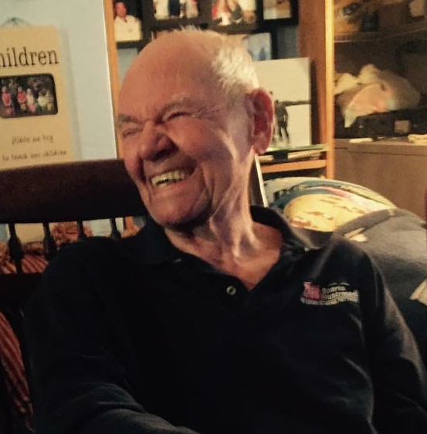
Jack Kinsner
May 29, 1923 – May 12, 2018
Jack H. Kinsner passed away on May 12, 2018, just two weeks shy of his 95th birthday.
He was preceded in death by Betty Bidner Kinsner, his wife of almost 64 years. He is survived by brother Jim Kinsner (Nancy) of Bowling Green, KY; daughters Kathy Kinsner (Josh Rubin) of NYC, Sue Pepper Warga (Tim) of Athens, OH, and Lisa Kinsner Scheer (Steve) of Avon Lake; companion Jean Lamvermeyer; grandsons Jack Pepper (Jordan), Rob Pepper (Melissa), and Patrick Pepper (Elizabeth); step-grandchildren Tim Warga (Heather), Tammie Laskowski (Jason), and Tessie Smith (Travis), 16 great-grandchildren, and his beloved Buick Lucerne.
Jack was born in Cleveland on May 29, 1923, and grew up in Avon Lake, OH. He served in the Army Signal Corps in France during WW II, and stayed on as the civilian wire chief in charge of rebuilding a communications network for all of France and part of Belgium. (He was 22.) He attended Ohio State, where he met his adored wife Betty. They married in 1951. Jack graduated from Ohio State with a degree in electrical engineering, and went to work for Cutler-Hammer selling motor control in Milwaukee, Pittsburgh, and Youngstown. In 1963, the family returned to Avon Lake, Jack’s favorite place on earth.
Jack had a long and successful second career selling real estate, and it was hard to go anywhere in the community without running into someone whose house he’d sold.
He was an active member of Kiwanis, the North Coast Community Woodshop, and Christ Evangelical Lutheran Church. For the past seven years, Thursday mornings found him at the Avon Lake Municipal Court, where he worked as a volunteer bailiff.
Jack loved being a grandpa and a dad, and had a large collection of T-shirts proclaiming his excellence at both. He was always up for an adventure or a good story, and he will be missed by all who knew him.
A celebration of his life will be held on Saturday, May 26, 2018, at 11am at Christ Evangelical Lutheran Church, 32747 Lake Road, in Avon Lake, OH. The family requests no flowers. Donations may be made to the North Coast Community Woodshop, Ames Family Hospice, or Christ Evangelical Lutheran Church.

